GLOBAL-SUPPERMARKET SALES PERFORMANCE ANALYSIS
1- Project-Overview
This dataset represents transactional sales data for a multinational supermarket operating across the United States, United Kingdom, Canada, Germany, and Australia, it contains 5,500 records, where each row represents a single customer transaction, the dataset combines: sales data, customer demographics, product details, shipping & delivery information, payment methods, return status, customer feedback (ratings).
2- Problem Statement
A multinational supermarket operating in the United States, United Kingdom, Canada, Germany, and Australia is facing inconsistent profitability, rising product returns, and fluctuating customer satisfaction across regions and product categories.
Despite strong sales volume, management suspects revenue leakage due to: high return rates in certain categories, Ineffective discount strategies, delivery delays impacting reviews, low conversion of repeat customers into high-value buyers.
The objective is to analyze sales, customer behavior, delivery performance: profitability drivers and loss factors, return risk indicators, customer retention opportunities, Region-wise performance gaps.
“The goal is to provide data-driven recommendations to improve profitability, reduce returns, and enhance customer satisfaction”.
3- Exploratory Data and Cleaning (Using Power Bi “Power-query”):
We began with data preparation and data cleaning in:
. Data loading: imported the dataset into power-query.
. Initial Exploration: Used the view - column distribution - column quality – column profile
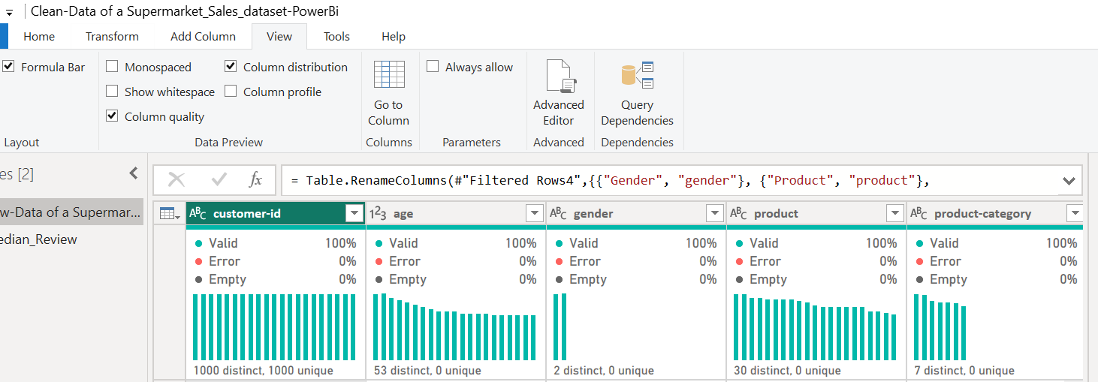
. Missing Data Handling: Checked for null values and imputed missing values in the Review Rating column, Sales-Price column, Quantity, and Unit Price, using the median rating of each product category for review rating, and remove rows where quantity or unit-price is null because a sale without quantity is invalid, a sale without unit price is price incomplete and financial records must be reliable.
. Columns Standardization: Renaming columns, changing data type.
. Creating Measures:

i- Return Rate % Measure:
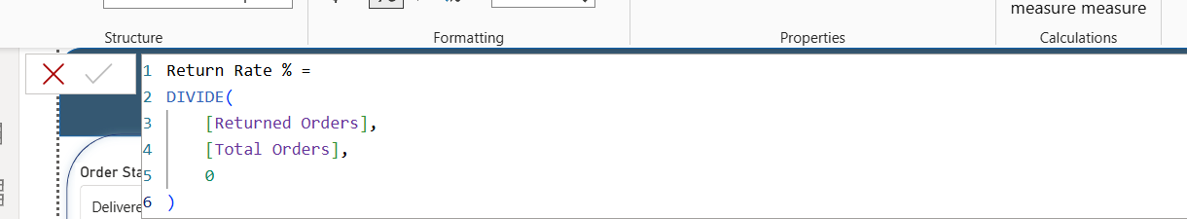

ii- Create Total Orders Measure:
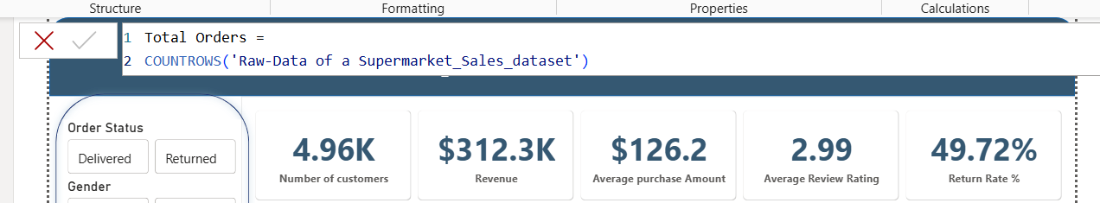

iii- Create Returned Orders Measure:
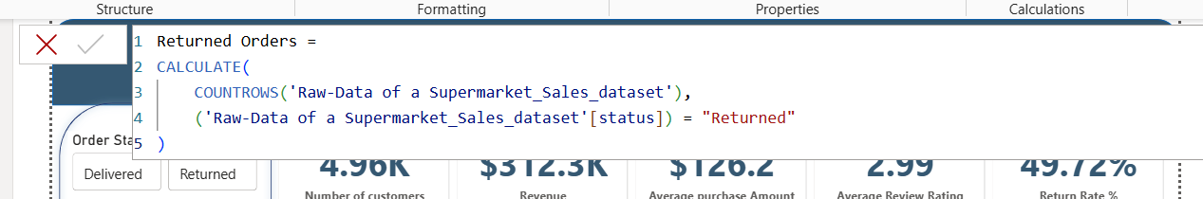

iv- Create Revenue Measure:
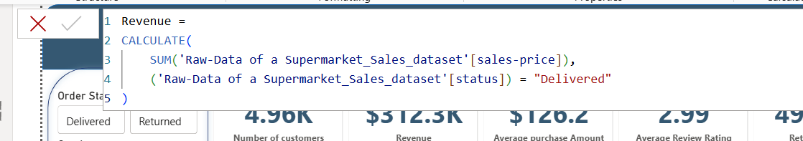

v- Create Average Review Rating Measure:
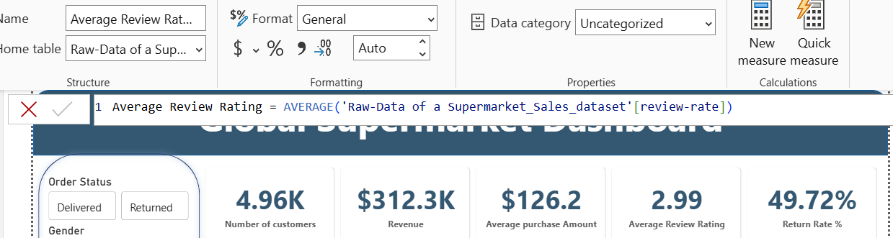
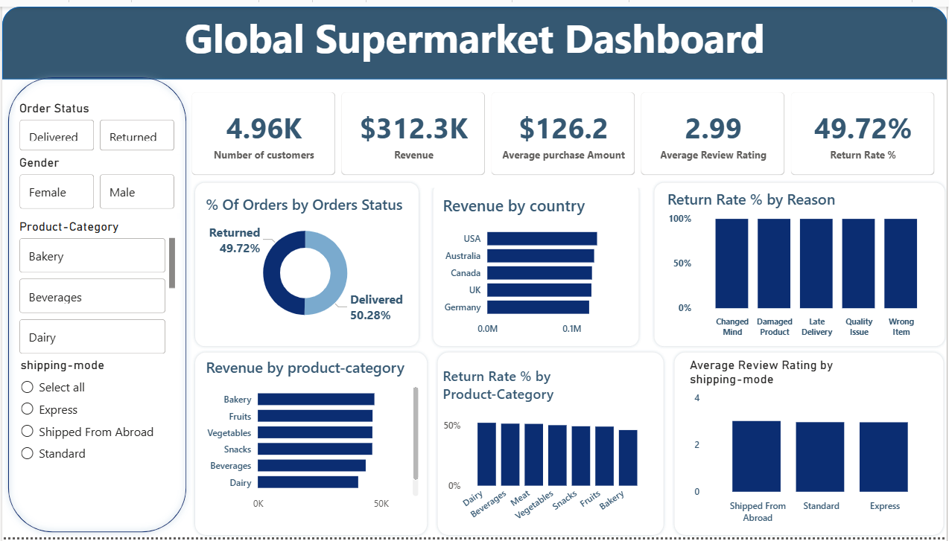
5- Dashboard in Power BI: Finally, we built an interactive dashboard in Power BI to present insights visually.

6- Recommendations:
. Improve Order Accuracy and Fulfillment Control: The analysis identified “Wrong Item” as a major return driver, indicating weaknesses in warehouse picking and fulfillment processes, so Improving order accuracy is expected to significantly reduce return rates, lower reverse logistics costs, and rebuild customer trust. This initiative directly addresses revenue leakage and is likely to generate immediate operational efficiency gains.
. Strengthen Quality Control for Perishable Products: Bakery, beverage, and fruit categories exhibit extremely high return rates, suggesting quality deterioration, packaging issues, or supply chain inefficiencies, and Enhanced quality control will reduce returns within high-risk categories, improve customer satisfaction in core grocery segments, and protect brand reputation across all operating regions.
. Optimize Delivery Performance: Late delivery accounts for a substantial portion of returns and negatively impacts customer ratings, so by Improving the delivery reliability will reduce return rates linked to delays, enhance customer satisfaction, and contribute to stronger retention and repeat purchase behavior.
. Redesign and Control the Return Policy Framework: The current return structure appears to allow excessive returns, contributing to profitability instability, A more controlled return framework will reduce opportunistic returns, protect profit margins, and encourage operational accountability while maintaining fair customer service standards.

